2.20.13 PHOTO - Feb Highlights Newsletter
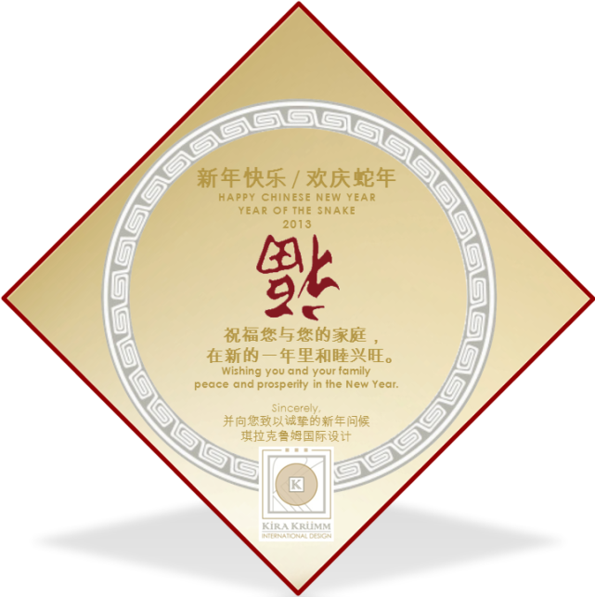

2.20.13 TEXT - Feb Highlights Newsletter
INTRO:
FEBRUARY 2013 NEWSLETTER: Happy Chinese New Year!
Happy Chinese New Year, Year of the Snake! Check out highlights from KKID including a sneak peek of our new bedding ensemble, Pearl, from the Kira Krümm Koastal Kollection, and our announcement that Kira will debut her luxury bedding Kollection at the largest furniture market in the world, in China, this March!

MAIN/LINK:
INSERT PDF - 2.20.13 PDF - Feb Highlights Newsletter

